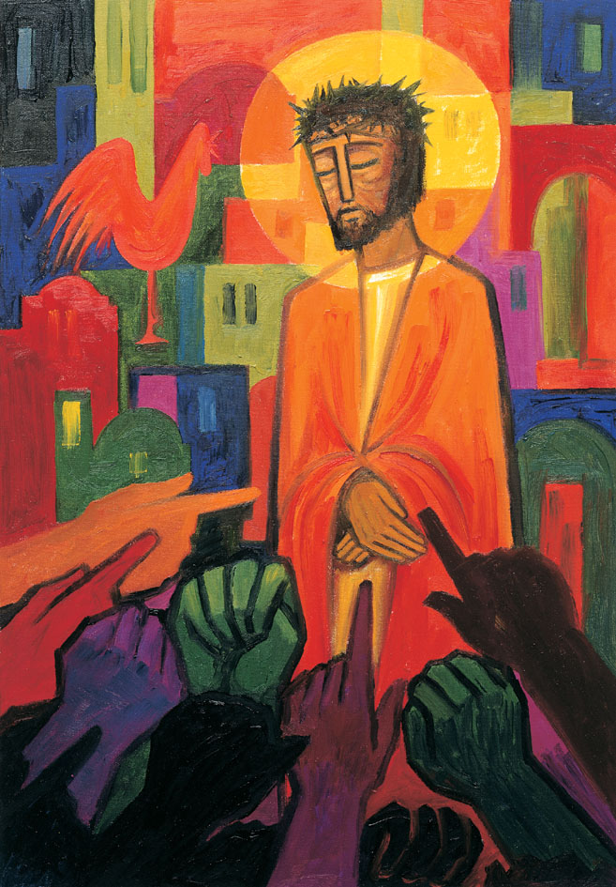
Daily thoughts on ‘The Footsteps of Christ’
Passiontide 2020.
Some thoughts and reflections using the images painted by the Benedictine Sisters of Turvey Abbey as published by McCrimmons.
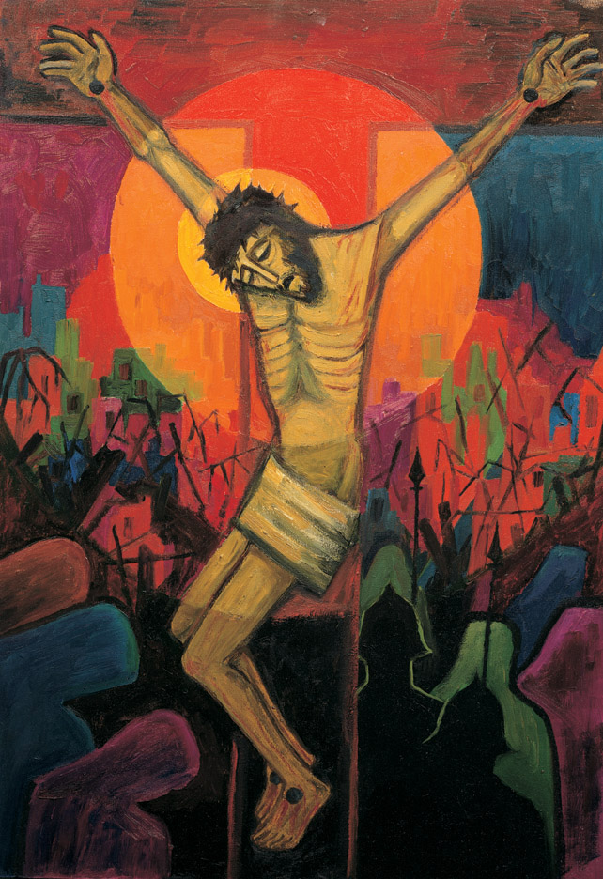
13 Jesus dies on the cross.

It was about midday and a darkness fell over the whole land, which lasted until three in the afternoon: the sun’s light failed. And the curtain of the temple was torn in two. Then Jesus uttered a loud cry and said, “Father, into your hands I commit my spirit”; and with these words he died.
Luke 23:44-47
Before the mystery of the death of our Lord Jesus on the cross we fall silent.
We know that, whatever suffering we have to undergo in this world, we are held in the hands of God. His cross is ours.
This is a scene reproduced in churches, art galleries, homes and jewellery across the world. In its familiarity it can become reduced to wallpaper. Novel when it is first hung, then simply merges into the ordinary so become barely noticeable. Yet this is the sign of sacrificial love that fuels our faith of the God who so loved the world that he gave his one and only Son.
This is the third image of Jesus upon the cross and the 13th in the series. I encourage you to notice the differences. For the first time we see blood upon flesh, bruising, a body emptied and contorted, desperate, life less. The breath has departed. The light is fading, the dazzling gone. The ground is once more filled with thorns, spears, helmets. Jesus seems to be sinking into the background and town scape. All but three people have turned their backs, walking away, job done. Problem over. Three remain (bottom left) in front, heads bowed in prayer and sorrow. Three faith-filled women.
Could they have believed at that very moment that this was not the end?
Could they imagine that ‘in three days time’ the world could be different?
For now, as the darkness falls, the light of the world seems to be extinguished. Hope gone, crushed by wrongs and forces beyond understanding but always with us.
Why would anyone be allowed to die like this?
I hope that when we are all able to meet again and share our ‘lock-down’ experiences we will learn something of each-others’ faithful resilience and surety of Immmanuel – God with us. We have been blessed to be in regular video link with children and grandchildren. We have known of Sophie, Luke, Daisy and Noah all needing specialist assistance. And with each call ‘Dad, the ambulance is coming’, I have just wanted to get in the car and go and be alongside. Turning to prayer has been foremost - waiting for the ‘It’s all right now’ message.
As the world pauses in the wake of the Covid-19 pandemic, so we have learned that at best we can pray:
‘Lord, into your hands I commend my spirit’.
for God is present….
For this time we are left to contemplate sacrifice, wrong, death
… and the love eternal love of that gives all to show is a better way.
When I survey the wonderous cross:
https://www.bing.com/videos/search?q=when+i+survey+the+wondrous+cross&&view=detail&mid=1277F7B6CB5956A991CF1277F7B6CB5956A991CF&&FORM=VRDGAR&ru=%2Fvideos%2Fsearch%3Fq%3Dwhen%2Bi%2Bsurvey%2Bthe%2Bwondrous%2Bcross%26FORM%3DHDRSC3

1 When I survey the wondrous cross,
on which the Prince of Glory died,
my richest gain I count but loss,
and pour contempt on all my pride.
2 Forbid it, Lord, that I should boast
save in the death of Christ my God;
all the vain things that charm me most,
I sacrifice them to his blood.
3 See from his head, his hands, his feet,
sorrow and love flow mingled down;
did e'er such love and sorrow meet,
or thorns compose so rich a crown?
4 His dying crimson, like a robe,
spreads o'er his body on the tree;
then am I dead to all the globe,
and all the globe is dead to me.
5 Were the whole realm of nature mine,
that were an offering far too small;
love so amazing, so divine,
demands my soul, my life, my all.
Isaac Watts (1674–1748)
Reproduced from Singing the Faith Electronic Words Edition, number 287 .

Continued…
Such has been the power of Jesu’s presence in peoples lives that two men ‘bravely’ feel lead to respond by asking that his body is given dignity is death.
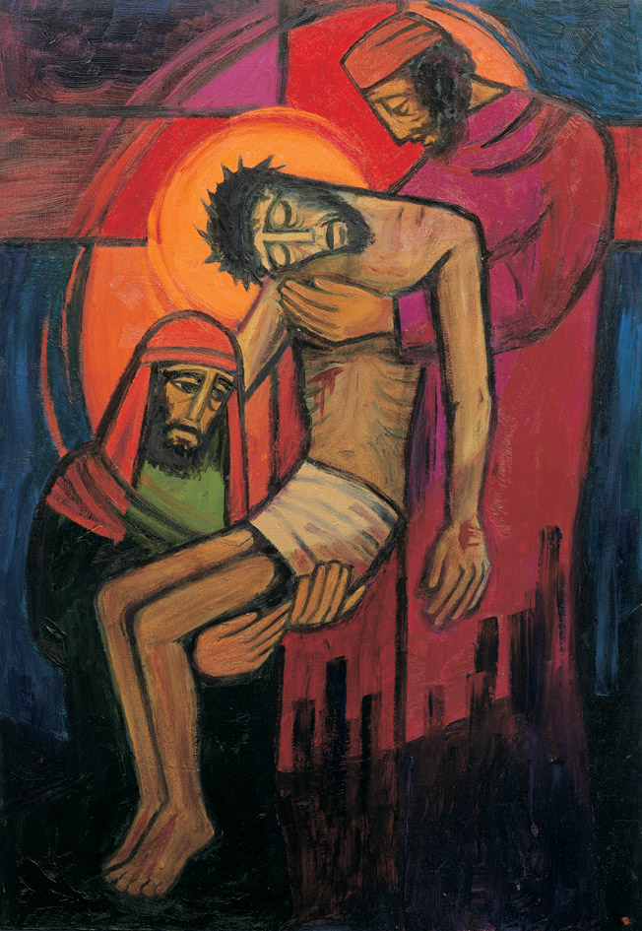
14. Jesus is taken down from the cross.

Joseph of Arimathaea, a respected member of the Council, a man who looked forward to the kingdom of God, bravely went in to Pilate and asked for the body of Jesus…
He gave Joseph leave to take the body.
So Joseph bought a linen sheet, took him down the cross, and wrapped him in the sheet.
Mark 15:43-46
Joseph of Arimathaea risked being identified as one of Jesus’ friend by asking for his body. He did not know about the resurrection, but unwittingly provided the scene for the events of Easter.

We pray:
Gracious God,
the comfort of all who sorrow,
the strength of all who suffer,
hear the prayers of your children,
who cry out to you in their need.
In their afflictions show them your mercy,
and give us, we pray, the strength to serve them,
for the sake of him who suffered for us,
your Son Jesus Christ our Lord. Amen.
Remembering those who had died,
all whose lives have ended in loneliness,
and all who have offered their loves for the sake of others,
and remembering the saints and martyrs in every generation,
that we also, inspired be their example,
may have grace to glorify Christ;
let us pray to the Lord.
Lord have mercy.
(a period of silence)
Almighty and everlasting God,
whose Son, Jesus Christ is the resurrection and the life:
set his passion, cross, and death
between your judgement and our souls,
now and in the hours of our death,
and bring us with the whole creation,
to the light and glory of your kingdom;
through Jesus Christ out Lord. Amen.

Some music to listen to. A setting of the ‘Leibestod’ – love in death – from the ending of Tristan and Isolde – Richard Wagner. A moment of intense passion and loving death. Just the music. Not with the vocals of Isolde longing to join he dead lover. There are other clips that is include stage settings. Try ‘google’.
https://www.bing.com/videos/search?q=liebestod+tristan+and+isolde&ru=%2fvideos%2fsearch%3fq%3dliebestod%2btristan%2band%2bisolde%26FORM%3dHDRSC3&view=detail&mid=51259DC6A5D59B17F0C051259DC6A5D59B17F0C0&&FORM=VDRVRV

Rev. Andrew Farrington

