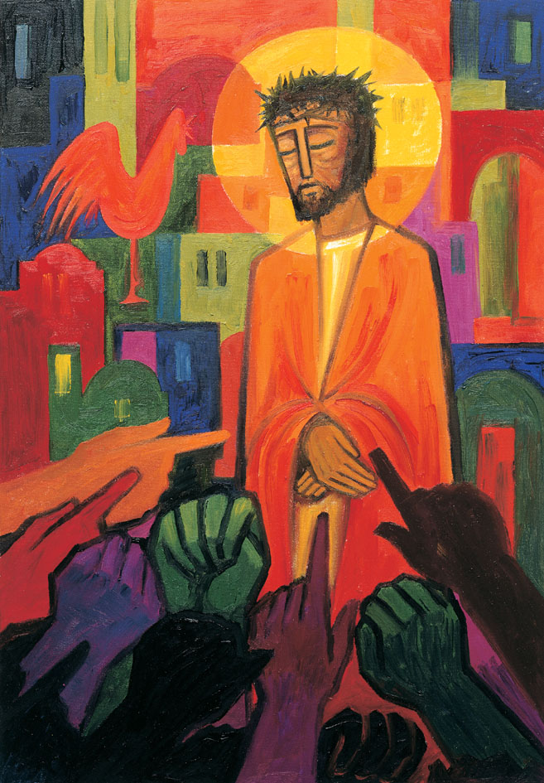
Daily thoughts on ‘The Footsteps of Christ’
Passiontide 2020.

Some thoughts and reflections using the images painted by the Benedictine Sisters of Turvey Abbey.
I reproduced the next two pictures in the series/ Each image is accompanied with the notes found in the booklet produced by the publisher, McCrimmons.

Rev. Andrew Farrington

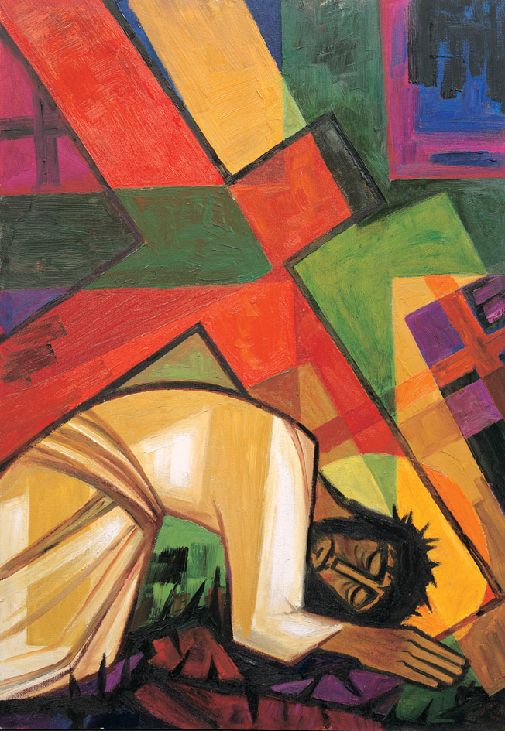
9 Jesus falls for the third time

The crosses are larger and heavier still, to the point of overwhelming Jesus.
He is crushed to the ground.
I am a man familiar with misery under the rod of his anger. I am the one he has driven and forced to walk in darkness and without any light. And now I say, ‘My strength is all gone, that hope which came from Yahweh.’Lamentations 3:1

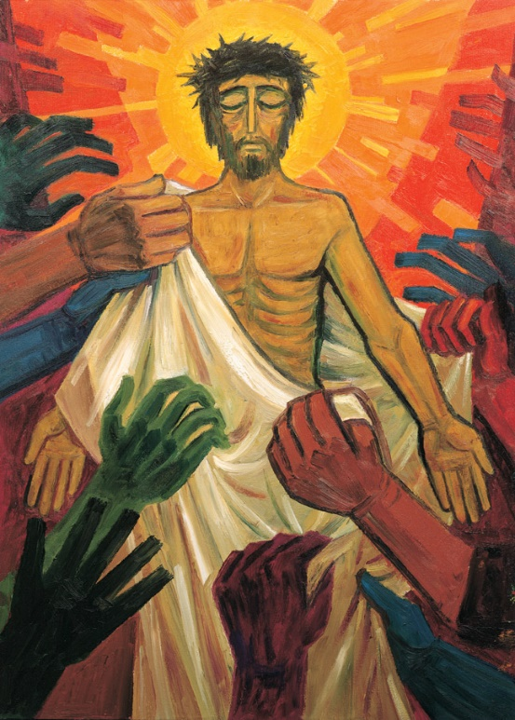
10 Jesus is stripped
When the soldiers had crucified Jesus they took his clothes and, leaving aside the tunic, divided them into four parts, one of each soldier. The tunic was seamless, woven in one piece throughout; so they said to one another, ‘We must not tear this; let us toss for it.’ Thus the text of scripture came true: “They shared my garments among them, and cast lots for my clothing.”
John 19:23-24
The lamb of God who takes away the sins of the world is prepared for sacrifice. His clothing is torn away from his body.
Love is revealed in its starkest form

I encourage you to review the previous ‘Jesus falls’ picture (3) & (6).
Gradually the weight of all the other crosses have bowed Jesus into complete submission. No Mary. No Simon. No Veronica. Nobody weeping. No one is left to rescue or offer help. Jesus is abandoned to the mire of the ground, subservient. Yet still he appears to be in a state of grace. Almost resting. Bowed and prayerful. Perhaps mindful of the pattern of service He had shown His friends just a few hours previously:

John 13: Jesus Washes the Disciples’ Feet
Now before the festival of the Passover, Jesus knew that his hour had come to depart from this world and go to the Father. Having loved his own who were in the world, he loved them to the end. ² The devil had already put it into the heart of Judas son of Simon Iscariot to betray him. And during supper ³ Jesus, knowing that the Father had given all things into his hands, and that he had come from God and was going to God, ⁴ got up from the table,^{[a]} took off his outer robe, and tied a towel around himself. ⁵ Then he poured water into a basin and began to wash the disciples’ feet and to wipe them with the towel that was tied around him. ⁶ He came to Simon Peter, who said to him, “Lord, are you going to wash my feet?” ⁷ Jesus answered, “You do not know now what I am doing, but later you will understand.”
Jesus gives all, bears all of our sins and wrongs, totally abandons self, in order that we might be repent, be forgiven, restored, absolved, set free. Set free to rejoice, set free to tell of the Christ who died, set free to humbly serve as ambassadors of the one true living God who takes away the sins of the world.
And we gaze in awe and wonder.
Jesus, Lord Jesus, you did this for me?
Me, who you could barely know?
Me, how can I deserve such grace?

The indignities continue. What value could there be in one piece of blood stained, road battered cloth? Very little. But they wanted everything. No respite. God to be stripped naked, the one who gave birth to all creation, stripped of everything except flesh and blood. The hunted trophy ready to be hung for all to see.
This is the only image I have misplaced. This perplexes me. Some years ago, I was called to a meeting where I knew I would simply be subjected to unwarranted abuse. I had one advantage. The meeting was in a place of my choosing. I set the room so that I could see this image whilst everyone else had their backs to it. The meeting proceeded as predicted. I managed to try and focus on the placidity of Jesus bearing patiently in a state of meditation as the last remnants were stripped away. ‘Thank you, Lord’, I prayed. ‘Give me the strength and forbearance to let men rage, may your peace reign in my heart, may my lips be silent, and may your grace be known’. Those who raged had their hollow human victory. But it was the love, peace, grace and hope of Christ’s sacrifice that triumphed. I often bring this image and experience to mind. It is one of great help and comfort.
The Serenity Prayer:
God, grant me the serenity to accept the things I cannot change,
courage to change the things I can,
and wisdom to know the difference.
Reinhold Niebuhr.

1 What kind of love is this
that gave itself for me?
I am the guilty one,
yet I go free.
What kind of love is this,
a love I’ve never known;
I didn’t even know his name —
what kind of love is this?
2 What kind of man is this,
that died in agony?
He who had done no wrong
was crucified for me.
What kind of man is this,
who laid aside his throne
that I may know the love of God —
what kind of man is this?
3 By grace I have been saved;
it is the gift of God.
He destined me to be his own
such is his love.
No eye has ever seen,
no ear has ever heard,
nor has the human heart conceived
what kind of love is this?
Bryn Haworth and Sally Haworth
Reproduced from Singing the Faith Electronic Words Edition, number 286
Words and Music: © 1983 Bella Music Ltd, 37 The Spinney, Epsom Downs, Surrey, KT18 5QX
.
For the music:
https://www.methodist.org.uk/our-faith/worship/singing-the-faith-plus/hymns/what-kind-of-love-is-this-stf-286/

For a video presentation:
https://www.bing.com/videos/search?q=what+kind+of+love+is+this+song&&view=detail&mid=0F8B68D7C147258FC4D70F8B68D7C147258FC4D7&&FORM=VRDGAR&ru=%2Fvideos%2Fsearch%3Fq%3Dwhat%2Bkind%2Bof%2Blove%2Bis%2Bthis%2Bsong%26FORM%3DHDRSC3

Every blessing,
Andrew

