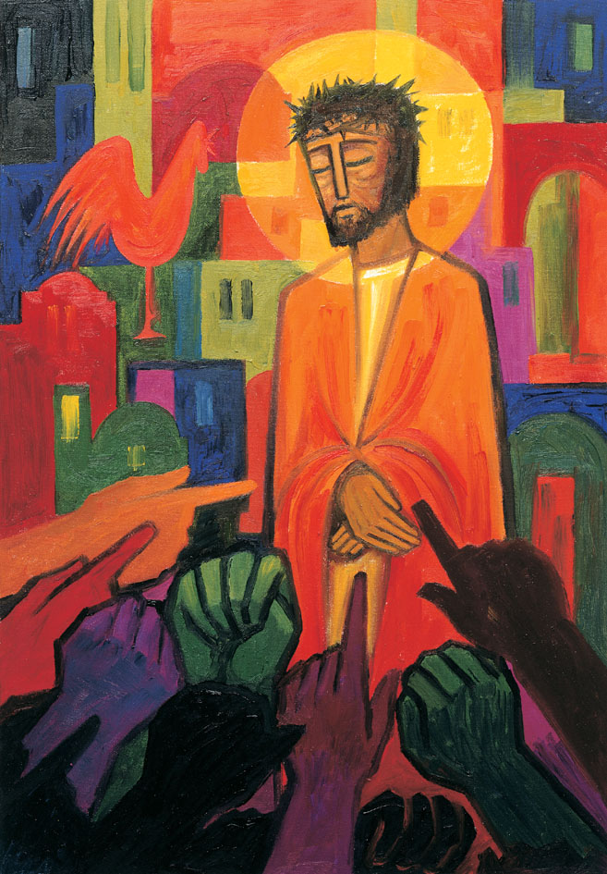
Daily thoughts on ‘The Footsteps of Christ’
Passiontide 2020.
Some thoughts and reflections using the images painted by the Benedictine Sisters of Turvey Abbey as published by McCrimmons.
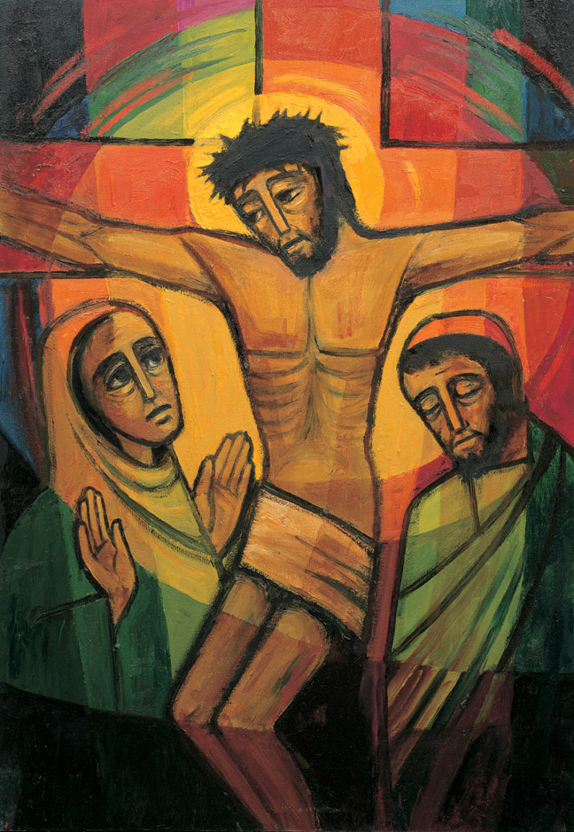
12 Jesus speaks to his mother.
Seeing his mother, with the disciple whom he loved standing beside her, Jesus said to her, “Mother, there is your son’; and to the disciple, ‘There is your mother’; and from that moment the disciple took her into his home.
John 19.26-27
A lasting relationship is established between Mary and John, soon to be filled with the presence of the risen Jesus.
These words are the words of a dying man. No thought for himself but for the two broken-hearted people who stood by the cross.

Continued…

Jesus is once more amongst friends. Arms fixed opened wide in constrained welcome. Not even nails will prevent Jesus offering the tender touch of word-filled breath. No agonised pleading, nor self-concern. Just desire to renew and restore relationships. Before Him are two significant people:
His Mother, whose own ‘Yes’ to the invitation of God’s will, is now comprehending the pain of bereavement. How difficult it is to let your children free to choose their own directions. Even more so, to see the Son of God yield to the only remedy left for the sins of the world. With the simplicity and economy of an expiring man, Jesus speaks through Mary’s anguish. “Do not let you hearts be troubled”, he had said, “and do not be afraid”. Jesus gifts to his Mary a new child to for her care – His troubled friend, Peter. “Mother, here is your son”. Five short words that transform relationships and horizons. God will always provide. Life goes on. Never abandon hope or cease to care. Always desire to offer the hand of fellowship.
His friend, Peter. Just hours before they had sat around a table, He had washed is feet, shared bread and wine, spoken of betrayal… yes, even Peter will deny Him. And he has. Jesus would have heard that cock crow as he abandoned His body to trial and torture. How would you have greeted a fair-weather friend who had left you in your time of crisis? ‘Go away from me Satan’? ‘Why are you here?’. Yet Peter is welcomed back like the Prodigal Son. He is brought even closer in the fold. Peter is offered a fresh start, and a family. Peace, peace always. How simple is this? Why do we find it so hard to achieve?
How incredible it is to comprehend the actions of Jesus at this moment. Relationships are restored. Peace and caring. Humility and humanity. Forgiveness is the watchword. ‘He died that we might be forgiven.

1 There is a green hill far away,
outside a city wall,
where the dear Lord was crucified,
who died to save us all.
2 We may not know, we cannot tell,
what pains he had to bear,
but we believe it was for us
he hung and suffered there.
3 He died that we might be forgiven.
He died to make us good,
that we might go at last to heaven,
saved by his precious blood.
4 There was no other good enough
to pay the price of sin;
he only could unlock the gate
of heaven, and let us in.
5 O dearly, dearly has he loved,
and we must love him too,
and trust in his redeeming blood,
and try his works to do.
Cecil Frances Alexander (1818–1895)
Reproduced from Singing the Faith Electronic Words Edition, number 284 .

For accompanying music, please follow:
https://www.methodist.org.uk/our-faith/worship/singing-the-faith-plus/search-results/?query=284

It is a tradition of this evening, that Churches are stripped of ornamentation, and people leave in silence.
I invite you to use the words of the hymn to reflect upon your relationship with Jesus.
How have you experienced His love?
How can you try to do Christ-like works?

Rev. Andrew Farrington

