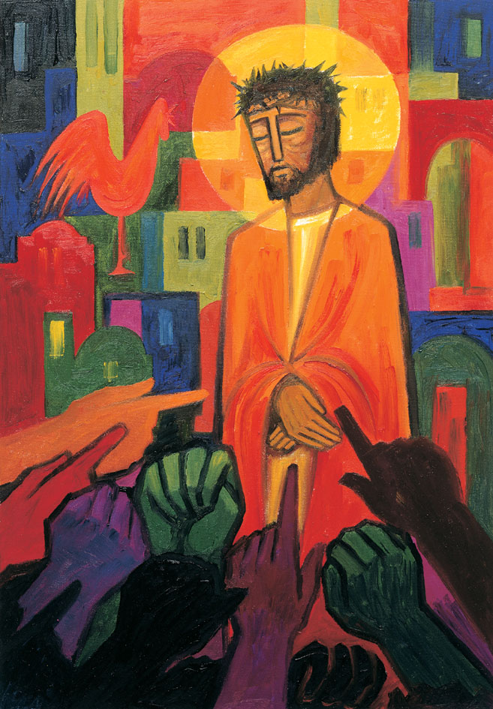
Daily thoughts on ‘The Footsteps of Christ’
Passiontide 2020.

Some thoughts and reflections using the images painted by the Benedictine Sisters of Turvey Abbey as published by McCrimmons.

Rev. Andrew Farrington

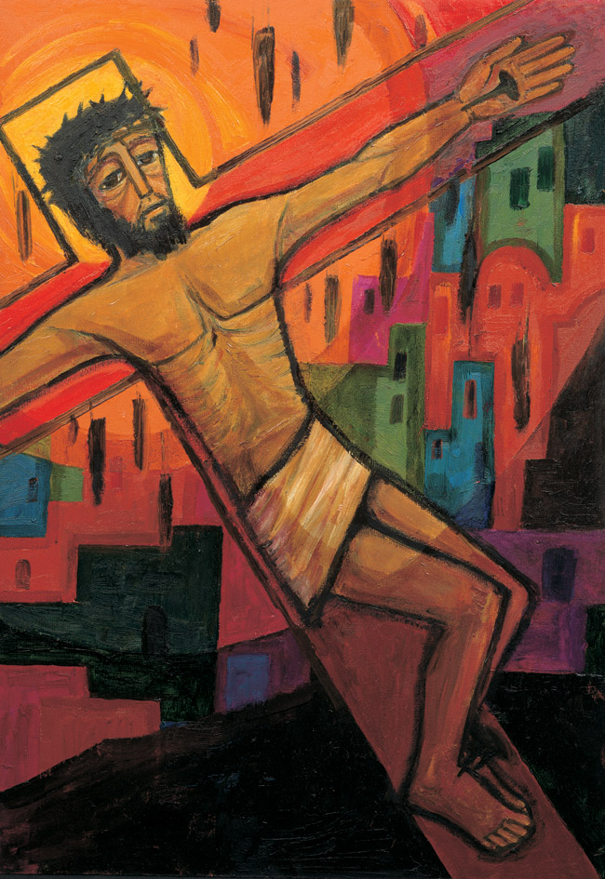
Jesus suffers in the agonies of the human race, until the end of time. (Pascal)
The body of Jesus, the Son of God, is now secured to the instrument of torture and people’s inhumanity to another is revealed
A man of sorrows and acquainted with grief. The air is filled with daggerlike droplets matching the skewing of the body to wood. The windows of the city take upon themselves a ghoulish foreboding presence. The light is dimming. A dark void is appearing. The shadows rise and mouth of the tomb is open, ready to receive.
Please open the separate PowerPoint file ‘Footsteps of Christ Day 8”.
Continued…
Then, I recommend watching this setting of ‘He was despised and rejected of men” from ‘Messiah’ by G. Handel.
https://www.bing.com/videos/search?q=man+of+sorrows+and+acquainted+with+grief&&view=detail&mid=FBF93EF8A68F832F46B0FBF93EF8A68F832F46B0&&FORM=VRDGAR&ru=%2Fvideos%2Fsearch%3Fq%3Dman%2Bof%2Bsorrows%2Band%2Bacquainted%2Bwith%2Bgrief%26FORM%3DHDRSC3
Open prayer of the liturgy for Good Friday, Methodist Worship book, p 255
Gracious and eternal God.
look with mercy on this your family,
for which our Lord Jesus Christ
was content to be betrayed
and given up into the hands of sinner
and to suffer death upon the cross;
who is alive and glorified with you,
in the unity of the Holy Spirit,
one God, now and forever. Amen

Rev. Andrew Farrington

