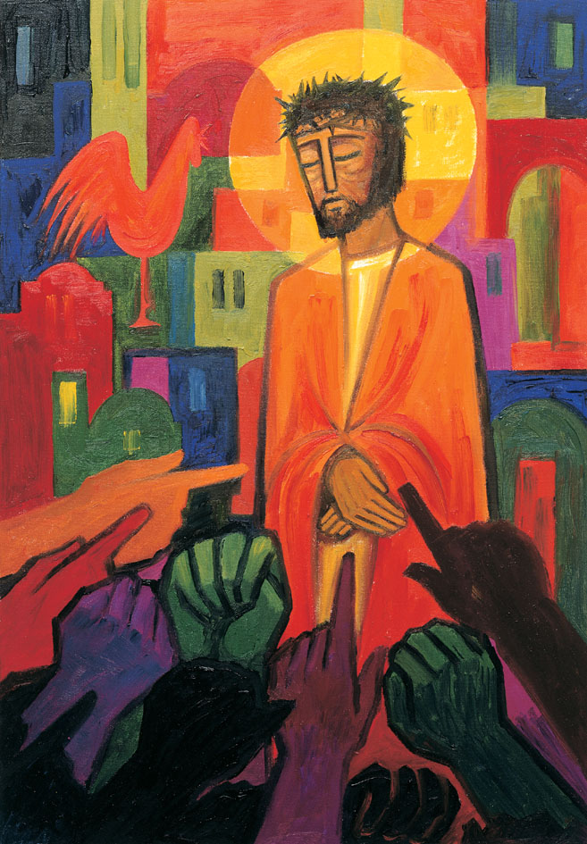
Daily thoughts on ‘The Footsteps of Christ’
Passiontide 2020.

Some thoughts and reflections using the images painted by the Benedictine Sisters of Turvey Abbey.

I have used a slightly different format today. The set includes 16 pictures and I am scheduling to show the 16th on Easter Sunday. To enable this schedule to work I have included three images today. The first two – ‘6. Veronica’ and ‘7 Jesus falls for the second time’ are supported by biblical accounts. For these I have simply reproduced the picture and notes that accompany them in the booklet produced by the publisher, McCrimmons.
The eighth is ‘The women of Jerusalem’ – and I have added my own commentary to this image.

Rev. Andrew Farrington

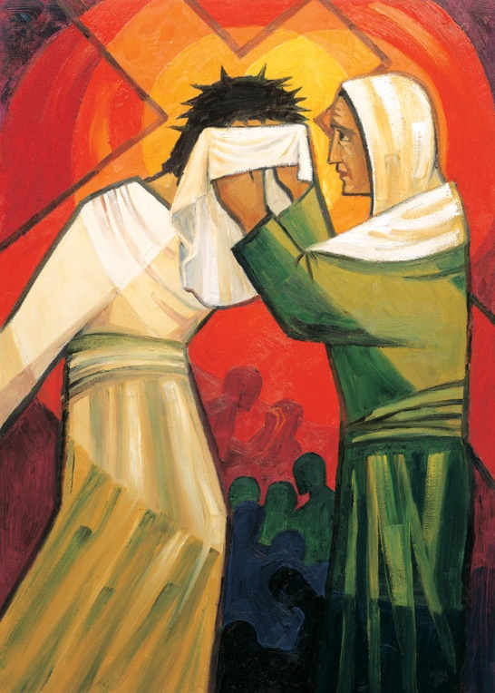
6 Veronica
Veronica wiped the face of Jesus because she saw before her a suffering person, not knowing that he was the Son of God.
Without beauty, without majesty we saw him, no looks to attract our eyes; a thing despised and rejected by men, a man of sorrows and familiar with suffering, a man to make people screen their faces; he was despised and we took no account of him.
Isaiah 53:2-3
Veronica means ‘true image’.
This incident is not recorded in the Gospels but it seems likely that the women who followed Jesus did what they could to ease his suffering.
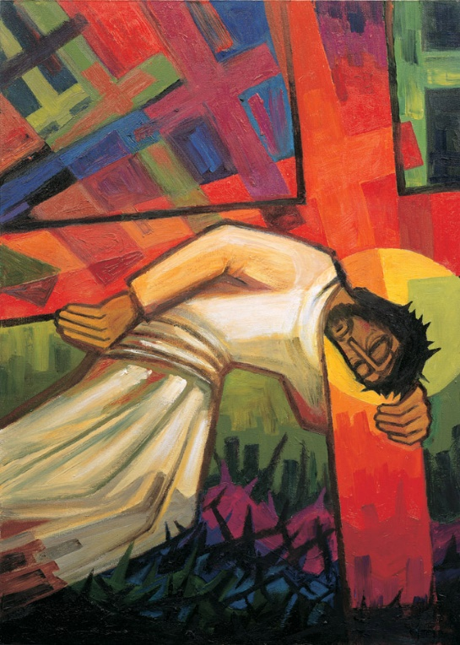
7 Jesus fall for the second time
Jesus falls because we fall.
He became like one of us,
so that we may become like him.
St Gregory of Nazianzen
His state was divine, yet he did not cling to his equality with God but emptied himself to assume the condition of a slave, and became as men are; and being as all men are, he was humbler yet, even to accepting death, death on a cross. Philippians 2:6-7
The crosses of the world which burden him, take on a more tragic dimension; they seem to batter him down, concentrating on his faltering figure to crush him totally and for good.

7 – Women of Jerusalem
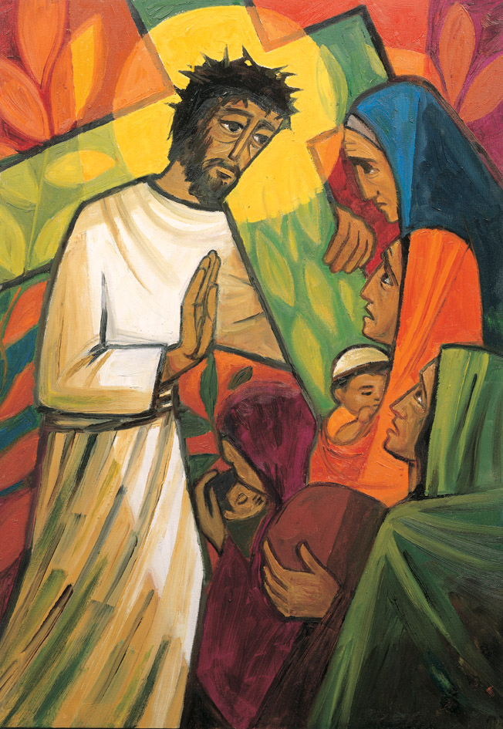
Great numbers of people followed, among them many women who mourned and lamented over him. Jesus turned to them and said: “Daughters of Jerusalem, do not weep for me; weep for yourselves and your children. For the days are surely coming when people will say, ‘Happy are the barren, the wombs that never bore a child, the breasts that never fed one.’… For if these things are done when the wood is green, what will happen when it is dry?”
Luke 23:27-31
The cross is represented here as bursting with life. The women too are life-bearers, through suffering.

On first reading, Jesus does not appear to be offerring the women much hope. This is not the whole picture. Jesus is lamenting with them. Here he is, the promised Messiah, the Saviour of Israel being driven to his execution in the very city, by the very people he came to save.He passees wry comment about those who cannot rejoice in the gifts they have received. As always, with Jesus, he offers a topsy-turvey (but perfect) solution: the first shall be last, the humble will be exhaulted, the lame walk, the blind see, the poor lifted, and the dead raised.
Jesus points to the potential bleakness of a world without him. Yet this is to conclude that the only outcome of the jourey to Golgotha will be death and burial.
What these women could not percieve (but we now know) is that this day was not the final day of Jesu’s life. New life is to emerge, even from death and tradegy. In time, the cross will be seen as a symbol of victory and hope. It will be worn and carried over the whole world as sign that Christ is alive and present in the lives of the bearer.
The cross of sacrifice is starting to shoot, the background burst into new life. And… in time…in this series of images.. we will see this motive again.
For now, I hope that you can reflect upon the three pictures in the centre of the series:
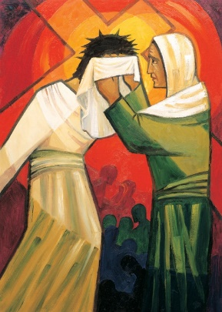
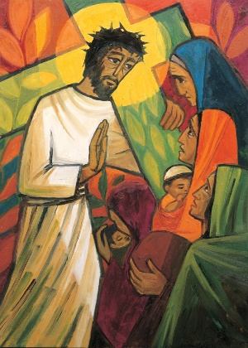
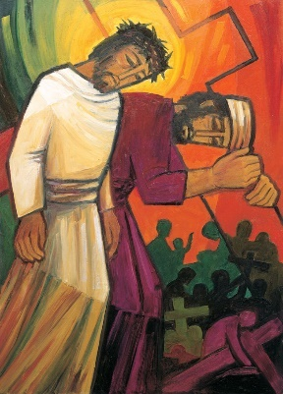

All three show moments of someone offerring care and support to those in great need. A time when the moment to assist and be present overrides any personal concerns.
^{“22}But the fruit of the Spirit is love, joy, peace, forbearance, kindness, goodness, faithfulness, ²³gentleness and self-control. Against such things there is no law. ²⁴Those who belong to Christ Jesus have crucified the flesh with its passions and desires. ²⁵Since we live by the Spirit, let us keep in step with the Spirit.” Galatians 5:22-26
When we know Christ deep in our heart and minds then we are able to let go of self and do the ‘Jesus’ thing and walk in tune with the bidding of the Holy Spirt. Against this, there is no law.
Hymn:

1 O the bitter shame and sorrow,
that a time could ever be
when I let the Saviour's pity
plead in vain, and proudly answered:
none of you and all of me!
2 Yet you found me; there I saw you
dying and in agony,
heard you pray, ‘Forgive them, Father,’
and my wistful heart said faintly:
some of you and some of me!
3 Day by day your tender mercy,
healing, helping, full and free,
firm and strong, with endless patience
brought me lower, while I whispered:
more of you and less of me!
4 Higher than the highest heaven,
deeper than the deepest sea,
Lord, your love at last has conquered;
grant me now my spirit's longing:
all of you and none of me!
Theodore Monod (1836–1921)
Reproduced from Singing the Faith Electronic Words Edition, number 432 .

Hyperlink to the tune:
https://www.methodist.org.uk/our-faith/worship/singing-the-faith-plus/hymns/o-the-bitter-shame-and-sorrow-stf-432/

Please pray:
giving thanks for times when you have known God’s presence most clearly.
giving thanks for those who have been present when you needed them most.
for those who you know and who are in need help.
for courage and strength to show the gifts of the Spirit to others.

Rev. Andrew Farrington

