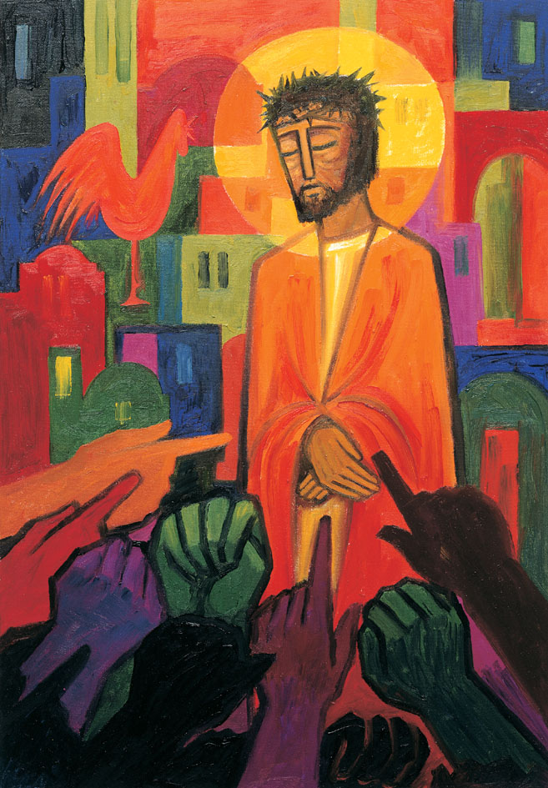
Daily thoughts on ‘The Footsteps of Christ’
Passiontide 2020.
Some thoughts and reflections using the images painted by the Benedictine Sisters of Turvey Abbey as published by McCrimmons.
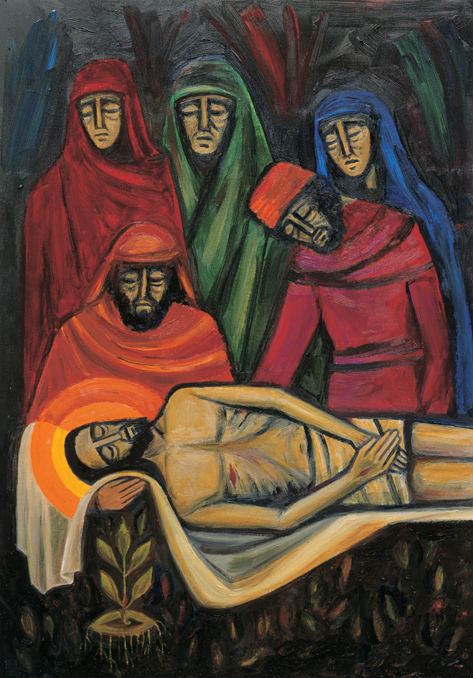
14 Jesus is buried.

Then he laid him in a tomb cut out of the rock, and rolled a stone against the entrance. And Mary of Magdala and Mary the mother of Jesus were watching and saw where he was laid.
Mark 15:47
The torment and agony of the crucifixion is over and Jesus is laid to rest. He is at peace, but his spirit rises and many of those who had fallen asleep are awakened.
In the deepest shadow of death there is a glimmer of the hope of a new life.
On a ‘normal’ Holy Week, you and I may have worshipped many time together and perhaps have left in silence on Good Friday. Holy Week can be a marathon to work though. Usually this day is, for me, a moment to try and reflect on my experiences through Lent and Passiontide and prepare an uplifting, happy, glorious, Easter Services. Ready to meet tomorrow in light and joy and proclaim the Easter message ‘His is risen’!
Holy Saturday is not a time we usually do anything in church. Yet it was, traditionally, in the early church the day in which who were preparing to be confirmed in their faith were baptised. After weeks of fasting and prayer there was a day of final preparation. To be lowered into the waters and be brought out again, cleansed and renewed. Waiting for the next day, waiting to receive the sign of the Cross, Holy Communion and entry into the Body of Christ, the church.
In some churches and Circuits’ I have offered a service of ‘renewal of baptism vows’. Maybe, next year we can explore this further.
In this image of the final events that occurred on Good Friday, we see the three women who have stood by Jesus to the very end watching as Jesus is placed to rest. A sad scene. I am ever mindful that this day many will die without the presence of families and loved ones around them. No final partings or words. Funerals to be arranged with no more than 10 close family attending. No viewing of bodies. A void that will be hard to bridge.
Even if we think that the darkness as overcome the light, here there is still a glimmer of the eternal flame of love. Here, just where Jesu’s head is coming to rest there is a small springing of life. The same flower we saw in the ‘Women of Jerusalem’ picture. We will see it again in all its glory.
Even in the emptiness of this Holy Saturday, God was still working His miracles. In Him we trust.

Rev. Andrew Farrington

