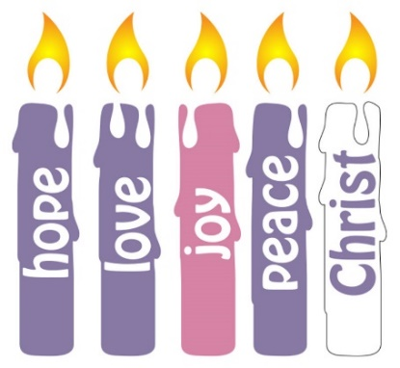**Kettering & Corby Methodist Circuit  
 Revised Notice Sheet: 19th December 2021**

‘Thoughts for the Day’ will be distributed by email   
and posted on the Cricuit web-site:  
https://www.ketteringcorbymethodists.org

We offer our thanks to all the Ministers, Preachers and Leaders of Worship.

**CORONAVIRUS: LATEST ADVISE RE USING CHURCH PREMISES**

Please follow this link for full details of the current advise:

<https://www.methodist.org.uk/for-churches/property/coronavirus-guidance-for-property/?utm_source=Methodist%20Church%20House&utm_medium=email&utm_campaign=12846387_The%20Methodist%20News%209%20Dec%202021&dm_i=BVI,7NCC3,HPGUAJ,V5LIZ,1>

**BASICS:**   
Unless you have a medical exemption, you **must wear a face-mask**   
throughout times of worship or fellowship meetings.   
Keep a sensible distance from other people.   
If you can, take a lateral flow test before attending.   
Do not attend if you have any symptoms of C-19 or have been asked to self-isolated.

Be safe. Take care of others. **Emmanuel, God is with us.**

**SUNDAY 19th DECEMBER**

**Central:** 10.30 a.m. Revd Noel Nhariswa Carols

**Cornerstone:** 10.30 a.m. Kate Horrix Carols  
**Rothwell:** 10.30 a.m. Revd Andrew Carols  
 Farrington & Christingle

  
 **St Giles Church:** 10. a.m. Revd Hannah Jeffery Family Service

**CHRISTMAS EVE  
FRIDAY 24th December**



**Central:** 4 p.m. Family Christingle Service  
 5 p.m. Revd Noel Nhariswa Holy Communion

**Cornerstone** 4 p.m. Community Carol Service

**Rothwell:** 11.30 p.m. Rev Andrew Farrington **Midnight Communion**

**St Giles Church**: several Christingle services, Road to Bethlehem, and Holy Communion – see St Giles Church web-site and Facebook pages.

**CHRISTMAS DAY  
St Giles Church**: 8.30 a.m. Revd Noel Nhariswa Holy Communion

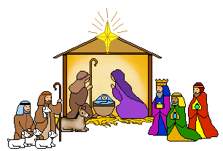10 a.m. Revd Hannah Jeffery Family Service

**SUNDAY 26th DECEMBER**An Order of Service Worship will be sent by email

**The following fellowship groups are closed,   
and will meet again in early January 2022**

**SUNDAYs  
BIBLE EXPLORATION WITH REV NOEL NHARISWA****TUESDAYs  
FELLOWSHIP** Rothwell Methodist Church 2.30 – 4.00 p.m.  
**CIRCUIT PRAYER MEETING 7.30 – 8 p.m.**   
**WEDNESDAYs   
BIBLE STUDY - Act of the Apostles with Rev’d Noel by Zoom**

**Knit & Natter.** Rothwell Methodist Church 10 -12 noon.

**THURSDAYs**  
**Mid-week worship** – *Cornerstone Methodist Church 1.30 – 2 p.m.*  
**TEA & chat** – Cornerstone Methodist Church 2 pm. -3 pm.  
**LAdies THURSDAY CLUB** – Rothwell Methodist Church 2 p.m.  
SEE St Giles Church Desborough web-site and Facebook page   
for details of the fellowship groups meeting.

Superintendent Minister: Minister:  
Rev. Andrew S Farrington Rev. Noel Nhariswa  
 07985 308637 07947 543770  
[andrew.farrington@methodist.org.uk](mailto:andrew.farrington@methodist.org.uk) [noel.nhariswa@methodist.org.uk](mailto:noel.nhariswa@methodist.org.uk)

Young Persons’ Worker: Lay Pastoral Visitor:  
Mrs Caroline Barrett Mrs Fiona Farrington   
07757 162944 07427 260623  
[youth@ketteringcorbymethodists.org](mailto:youth@ketteringcorbymethodists.org) [fiona-farrington@utlook.com](mailto:fiona-farrington@utlook.com)