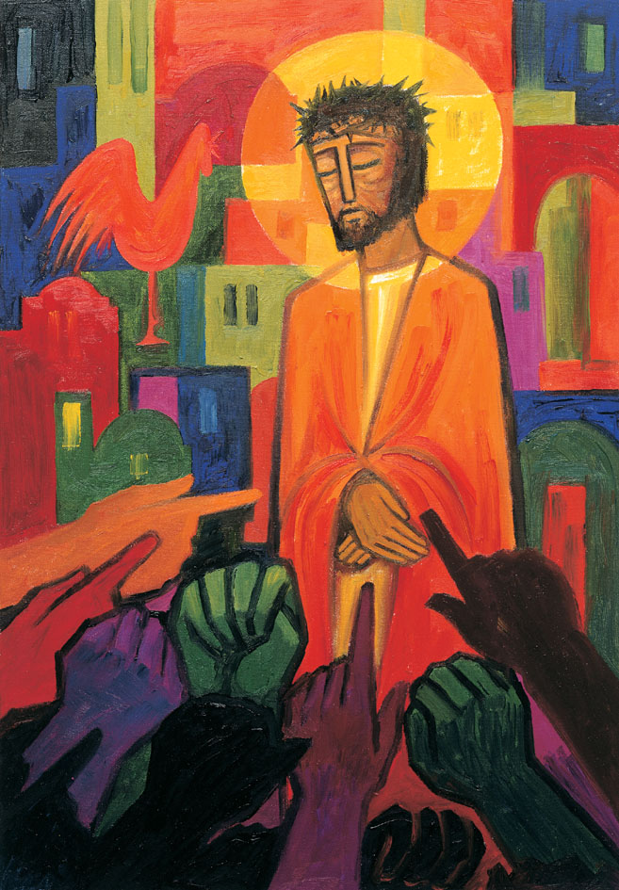
Daily thoughts on ‘The Footsteps of Christ’
Passiontide 2020.

Some thoughts and reflections using the images painted by the Benedictine Sisters of Turvey Abbey.
You may find it helpful to print pages 3 and beyond whilst retaining page 2 (with the painting) on the screen of your computer or device.
Rev. Andrew Farrington

4 - Jesus meets his mother.
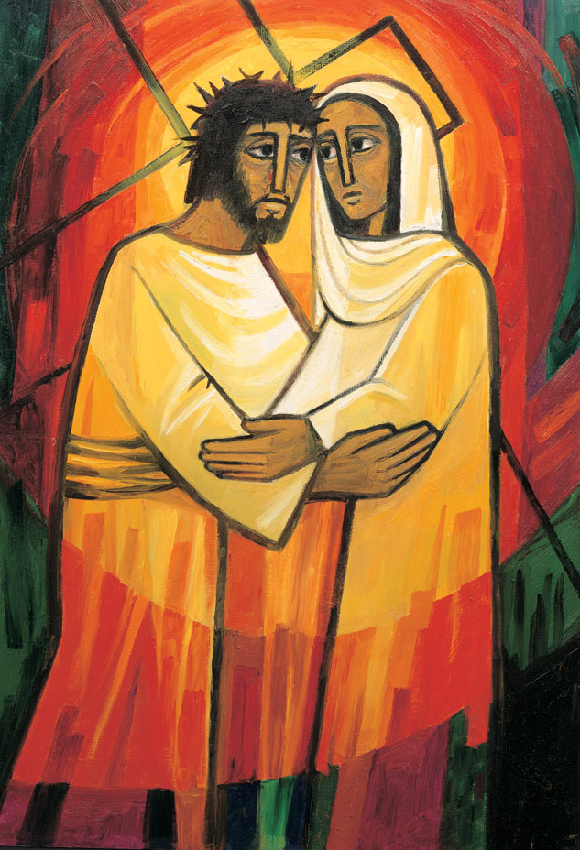
This station shows an obvious relief from the previous one. Mary’s nearness breaks through the nightmare with light and love; the colours reflect this. Mary was the one who was most able to help and strengthen him, while:
…the sword pierced her own soul.
Luke 2:35
It is the sword in Mary’s heart that now unites Mother and Son,
comforting each other.
Only when we know suffering ourselves,
can we comfort others.

There is great warm in this picture. The eternal light radiates through Jesus and Mary as they hold each other softly. Red, the colous of love, the colour of Mary glows around. Gone are the thorns, the crowds and crosses of others. This is a moment when the trials of the world are temporarily stripped way. Deep, personal, momentaritly uninterrupted pastoral care. With a sure gaze they see into each others minds and souls and offer each other unspoken love.
‘How silently, how silently, the wonderous gift is given, How silently, how silently the wondrous gift i
So God imparts to human hearts the blessings of his heaven.
(O little town of Bethlehem – Christmas Carol)
Her the mother of the Son of God might recall Jesus teaching about leaving father and mother, and about being in his Father’s house. Of Simeon’s warning that her heart would be pierced, and of the surety of Anna, Simeon, and Zechariah that her child will be for the redemption of Israel.
Redemption refers to the deliverance from some evil or bondage by payment of price or ransom. The cross of Christ is the is the price paid to set us free from sin. It is wondrously given, feely, to you and I when we know Jesus as Lord. The blessed gift of redemption, forgiveness, change to repent and turn around, and gain eternal life.
It has a human cost. Mary bears witness to price her son will pay for us. Love, overwhelming love.
All tinged with deep sadness. ‘No parent should see their child die’. We hear this emotion expressed time and again. Yet, her is Mary taking one last embrace longing for another outcome. In all too short a time the fleeting moment of care will pass. For Jesus will be moved on and once more Mary will be left as a silent witness to her innermost turmoil and distress: ‘I am the Lord’s servant, may it be to me as you have said’. (Luke 1:38)
And many, even now, are waiting at home for news of loved ones in closed hospital wards.
May the presence of Christ fill their lives; bring them peace; bring them well-being; calm the anxious, strengthen and skill the caring. Amen
Hail Mary full of Grace, the Lord is with thee.
Blessed are thou amongst women and blessed is the fruit of thy womb Jesus.
Holy Mary Mother of God,
pray for us sinners now and at the hour of our death
Amen.

